The winter volunteer event I wish to share about is the success of the Birdhouse Making and Wood Workshop six class series; ending in a Bird Walk and Birdhouse Installation Celebration finale.
Many things happened that suggested to me it was time to invite people to Awbury to volunteer to build something Awbury needed while those participating could acquire basic woodworking skills. First, I had a regularly visiting group who requested to fix the old birdhouses sitting on the edges of the Cope house. Also, I knew just the volunteer I wanted to draw back to Awbury to lead this birdhouse, woodworking skill endeavor. Larry Moyer, our sorely missed volunteer steward. I had to convince Larry, an excellent craftsman and retired high school History teacher that we could do this. I showed Larry the 4-H pamphlet with blueprints I had uncovering left for years from a past endeavor in a file drawer. Finally, there had been a recent anonymous blue birdhouse donation sitting, lonely, on Awbury’s work space shelves just calling our names. I felt now was the time to try to give this a go.
Things did not move as quickly as I had expected which in retrospect was well worth it. Larry and I went through piles of abandoned scrap wood behind the white barn only to come up empty handed. And I had had no clue about the details. Sure, we had old birdhouses to fix, and how hard could it be to make a birdhouse? But there were plenty of more questions to answer behind those. Where would we find the space to make them for several weeks in a row? And where would we get the tools and the materials to make them?
As luck would have it, beginning the workshop in January would make it perfect timing at the end of six sessions to install bluebird houses in the landscape in mid- February according to expert advice. This bought us a little time. With Larry’s tools and materials list in hand I wrote to the manager and neighbor at Tague Lumber. Blessedly, they filled the order. The space, donated by Karen who promised to reserve for us the shed space to hold the wood workshop.
As plans continued to unfold, and my husband’s mancave, propane heater was moved into place the shed took on more stature around the Cope House garden. Thanks to Larry’s teaching preparations and commitment throughout the process to rely on, all I thought I had left to do now was find the volunteers. Heather, always considering the community teaching moment aspect, suggested we could finish the workshop with a public event that could include a bird walk with the birdhouse installation. And another community event was created.
Denis Lucey generously offered to lead the walk in February. Who would have imagined it would be a 65F the day of the walk? And who knew that Awbury’s resident Audubon member, citizen scientist, Bill Reaume would invite us to Awbury’s winter bird count? Or that the Morris Arboretum would run an article in their winter news magazine about their successful bluebird house bird monitoring program that I would happen to open to read at the breakfast table one morning mid January? I called writer, Jessica Slade who offered to tour us through Morris’s bluebird monitoring program. On a beautiful warm winter day in January, Larry and I had the pleasure of Jessica’s undivided attention. She shared just about every aspect of the structural system and research that built their program. And she wouldn’t let us leave until we peered into the house of a bluebird. There sat a beautifully naturally made bluebird nest. Built to nature’s specifications. But are our houses good enough only set on ½” conduit poles?
Through it all we always had the support, enthusiasm and sense of calm from our volunteers in class. On average, we had four to five people at a time, in the wood working room which was as most as the shed could hold. Severe subfreezing temperatures only happened on the first day. We moved the introduction inside and crossed our fingers the participants believed us. Some couldn’t be there through all the sessions but other new ones arrived to help the teamwork and skills development continue with a single goal in mind, to give birds at Awbury our support in their struggle to survive in Philadelphia’s urban jungle.
Late to the game, but bearing gifts for our feathered friends was a post workshop participant who donated several personally and skillfully made birdhouses to the cause. Now, it feels like we are sitting pretty. Twenty-four people participated in the bird walk and birdhouse installation finale on February 19th. And four bluebird houses that weren’t there before stand peacefully waiting for their visitors to see if they will like it and stay.

Most Truly Yours 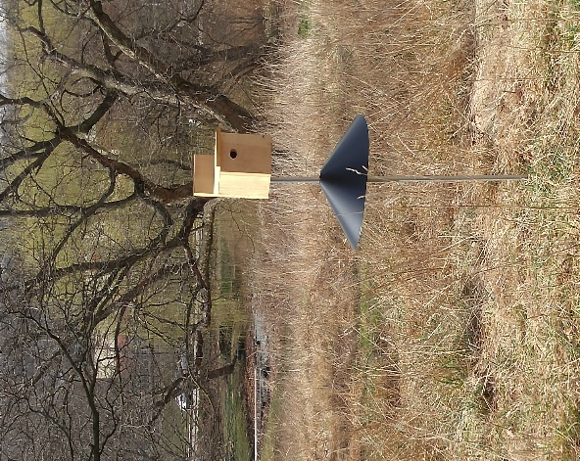
Leslie Cerf

